ITA1471

**ETHICAL HACKING FOR NETWORK HACKING**



# C.Rajitha

192211394

**1St YEAR, CSE DEPARTMENT**

**ITA144-ETHICAL HACKING**

**LAB MANUAL**

## Exercise No 1: Nmap Scan

**Aim:**

To install and perform Nmap scan (note :- you may use ip address or website name)

**Procedure:**

Step 1: Open Nmap from Kali Linux (Goto Applications->select Information Gathering->select

Nmap)

Step 2: Perform different types of scan

(Tcp, Udp, Ack, Syn, Fin, Null, Xmas, Rpc, Idle)- scan types

**Scanning Techniques**

**Flag Use Example**

**-sS** TCP syn port scan nmap -sS 192.168.1.1

**-sT** TCP connect port scan nmap -sT 192.168.1.1

**–sU** UDP port scan nmap –sU 192.168.1.1

**–sA** TCP ack port scan nmap –sA 192.168.1.1

### Step 3:-

To perform host discovery

|  |  |  |
| --- | --- | --- |
| **-Pn** | only port scan | nmap -Pn192.168.1.1 |
| **-sn** | only host discover | nmap -sn192.168.1.1 |
| **-PR** | arp discovery on a local network | nmap -PR192.168.1.1 |
| **-n** | disable DNS resolution | nmap -n 192.168.1.1 |

### Step4:-

**Port Specification**

**Flag Use Example**

**-p** specify a port or port range nmap -p 1-30 192.168.1.1

**-p-** scan all ports nmap -p- 192.168.1.1

**F** fast port scan nmap -F 192.168.1.1

### Step 5:-

***Service Version and OS Detection***

Flag Use Example

|  |  |  |
| --- | --- | --- |
| **-sV** | detect the version of services running | nmap -sV 192.168.1.1 |
| **-A** | aggressive scan | nmap -A 192.168.1.1 |
| **-O** | detect operating system of the target | nmap -O 192.168.1.1 |

### Step 6:-

Timing and Performance

Flag Use Example

|  |  |  |
| --- | --- | --- |
| **-T0** | paranoid IDS evasion | nmap -T0 192.168.1.1 |
| **-T1** | sneaky IDS evasion | nmap -T1 192.168.1.1 |
| **-T2** | polite IDS evasion | nmap -T2 192.168.1.1 |
| **-T3** | normal IDS evasion | nmap -T3 192.168.1.1 |
| **-T4** | aggressive speed scan | nmap -T4 192.168.1.1 |
| **-T5** | insane speed scan | nmap -T5 192.168.1.1 |

Output:

1)

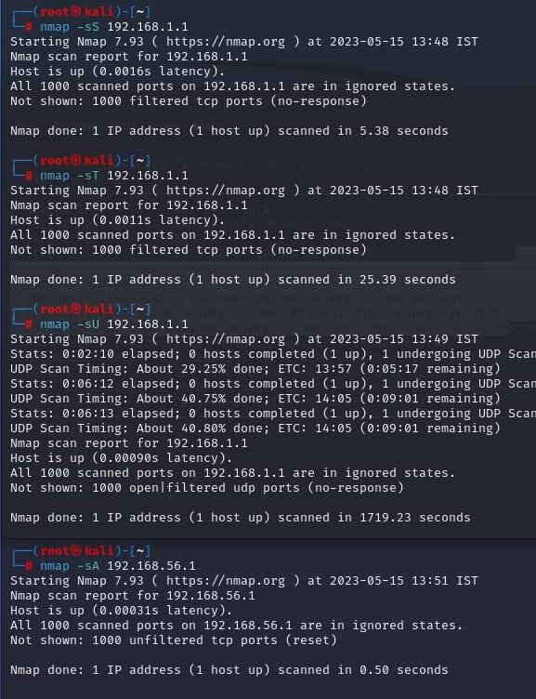

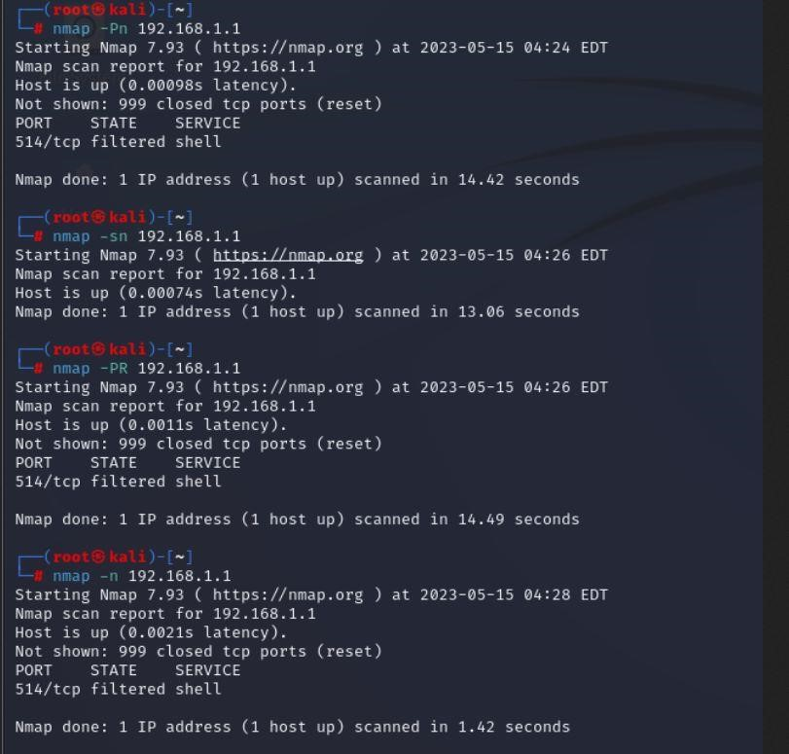

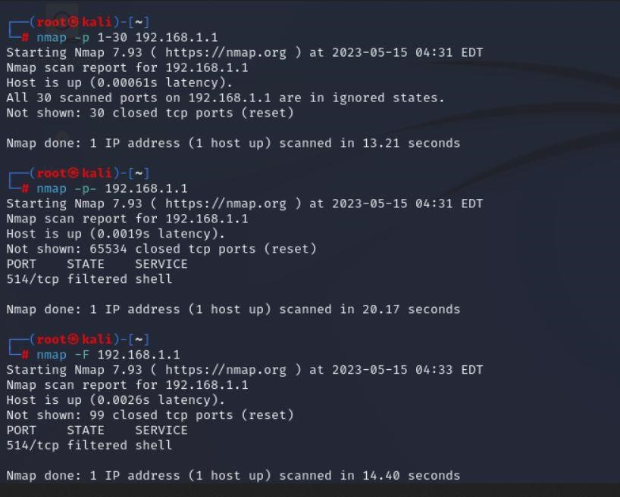

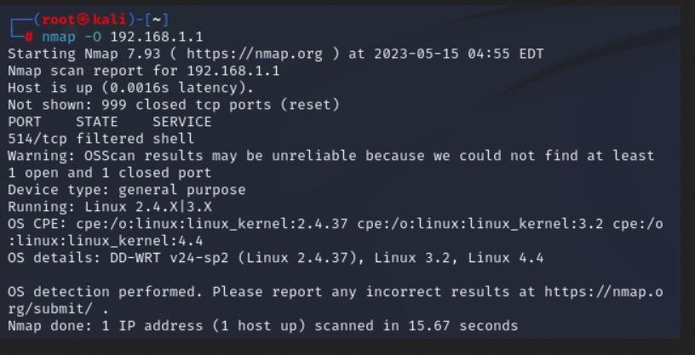

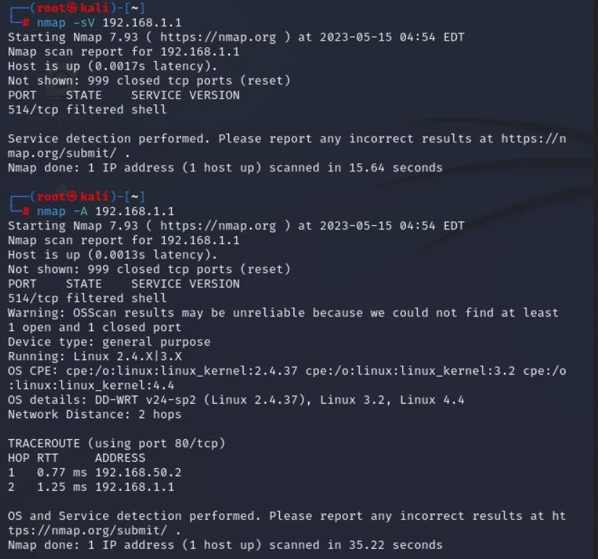

**Result:**

The following experiment is done using Nmap tool in root terminal in kali Linux server. I have used all the commands that are available in Nmap tool.

**Exercise No 2:** **Vulnerability Access Scan Using Nessus**

**Aim :** To Download and install Nessus tool and perform a Vulnerability Access scan in kali Linux Operating systems.

Step 1:-<https://www.tenable.com/downloads/nessus?loginAttempted=true>

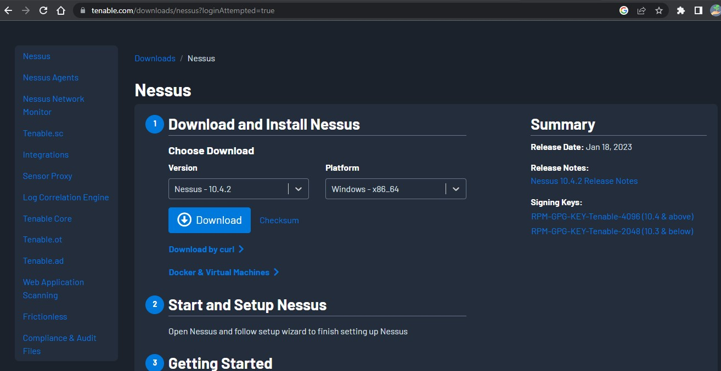

Step 2: Choose your OS and download , install

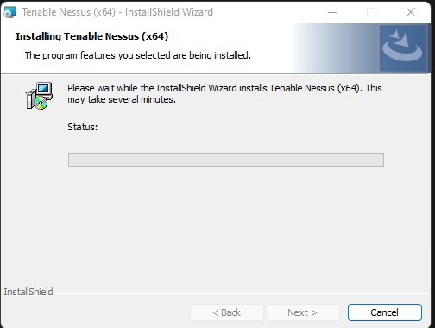

Step 3: Once installation is completed it will open in default browser

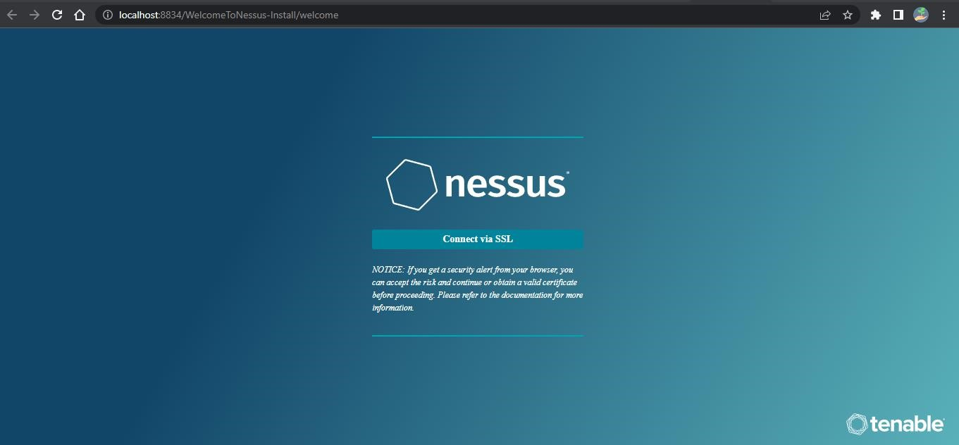

Step 5:- (click on the proceed to local host)

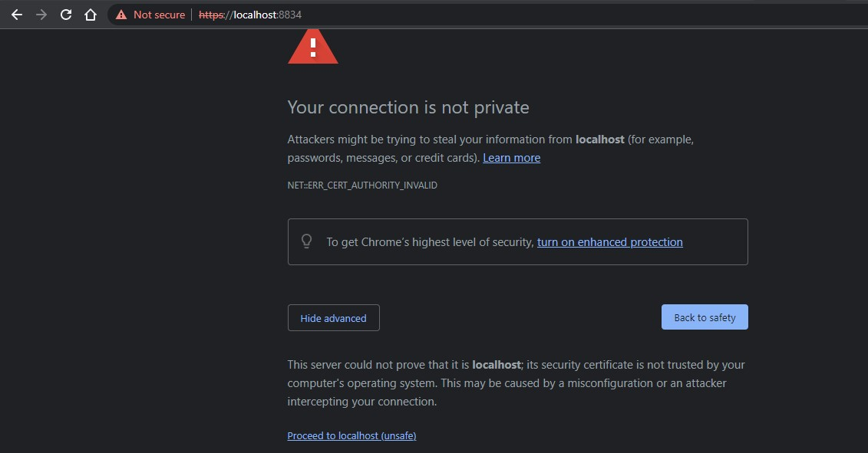

Step 6:- Please choose the Nessus Expert

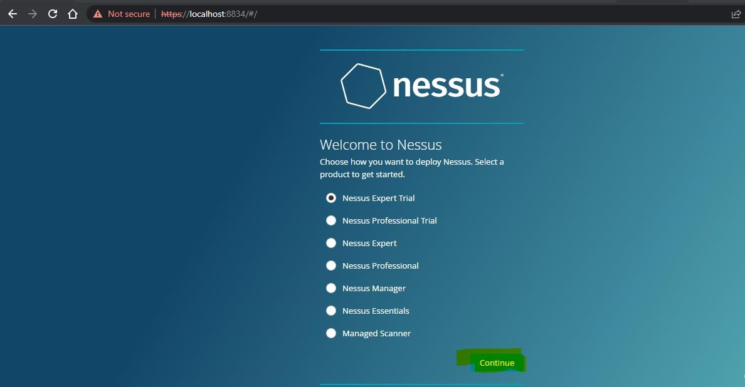

Step 7: Click on continue

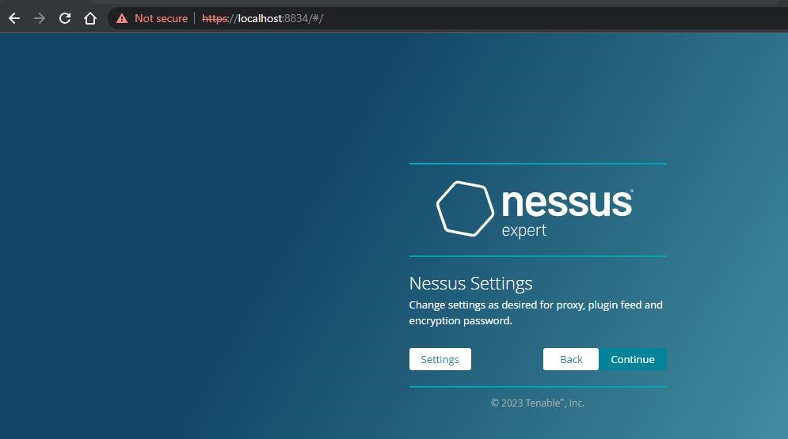

Step 8:- Register with your organizational email id

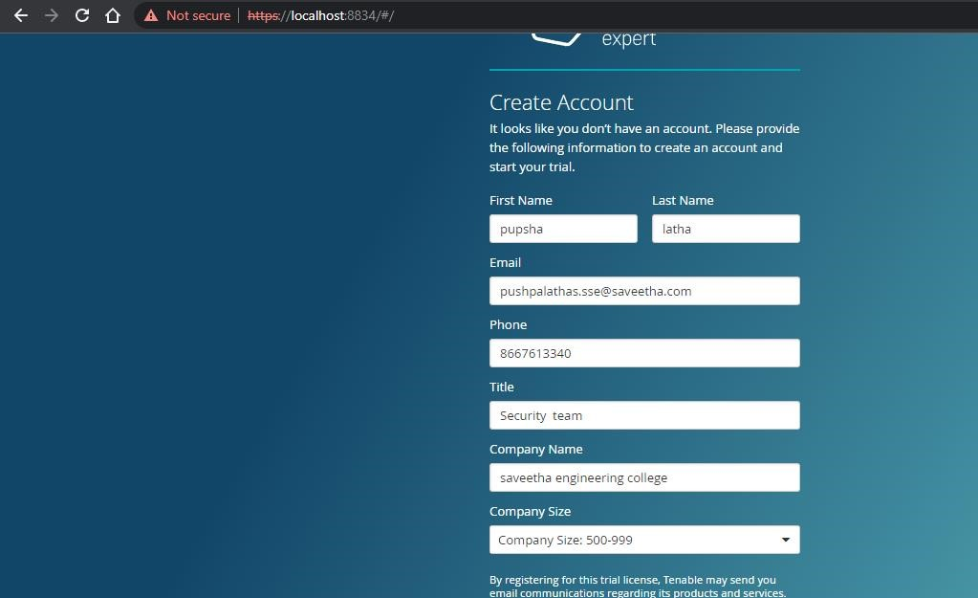

Step 9:- please note down the activation key

**Trial License Information**

Activation Code: R4A2-DPDT-UVQZ-T53Y

Valid until: 2023-01-28

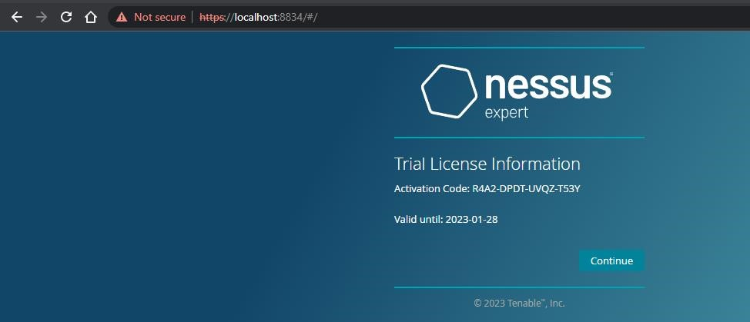

Step 10:- set up your username & password

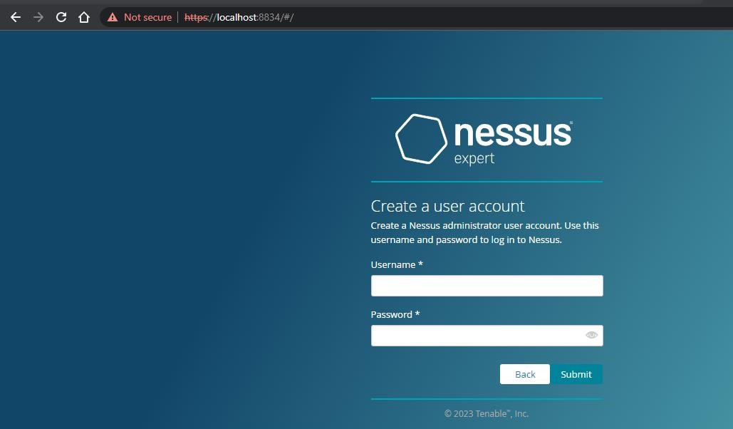

Step 11:-Type username and password

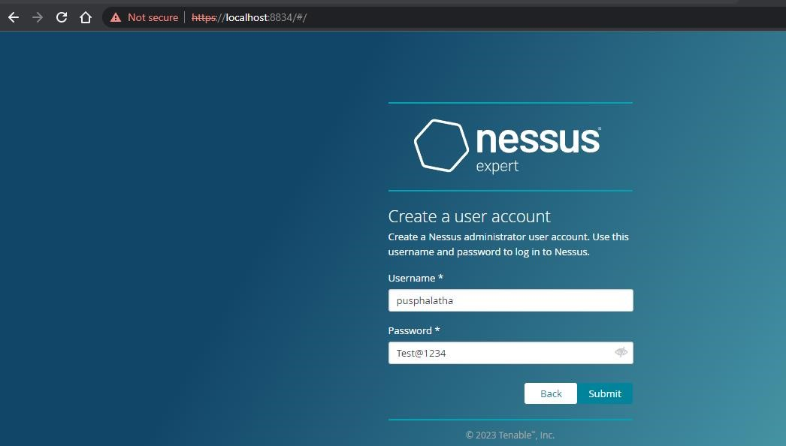

Step 12:- Please wait until download is completed

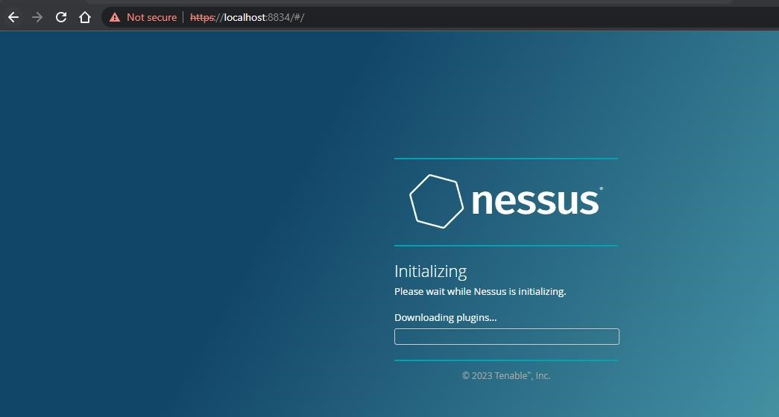

Step 13: Select My Scans

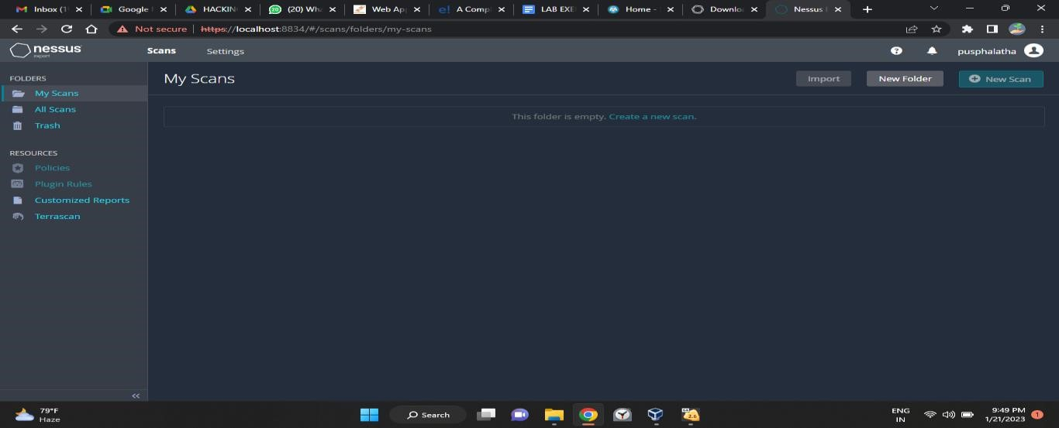

**Output:**

1)

2)

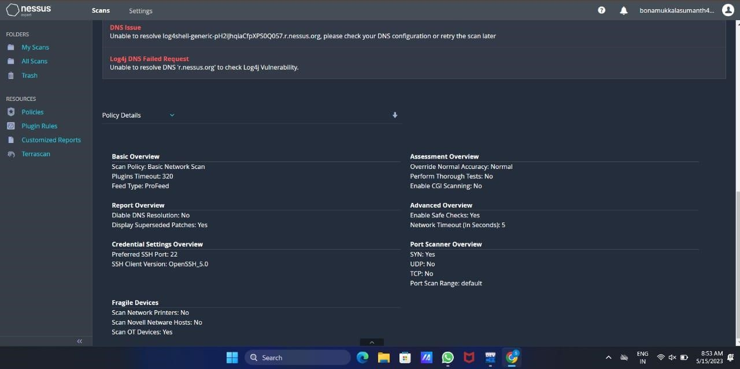

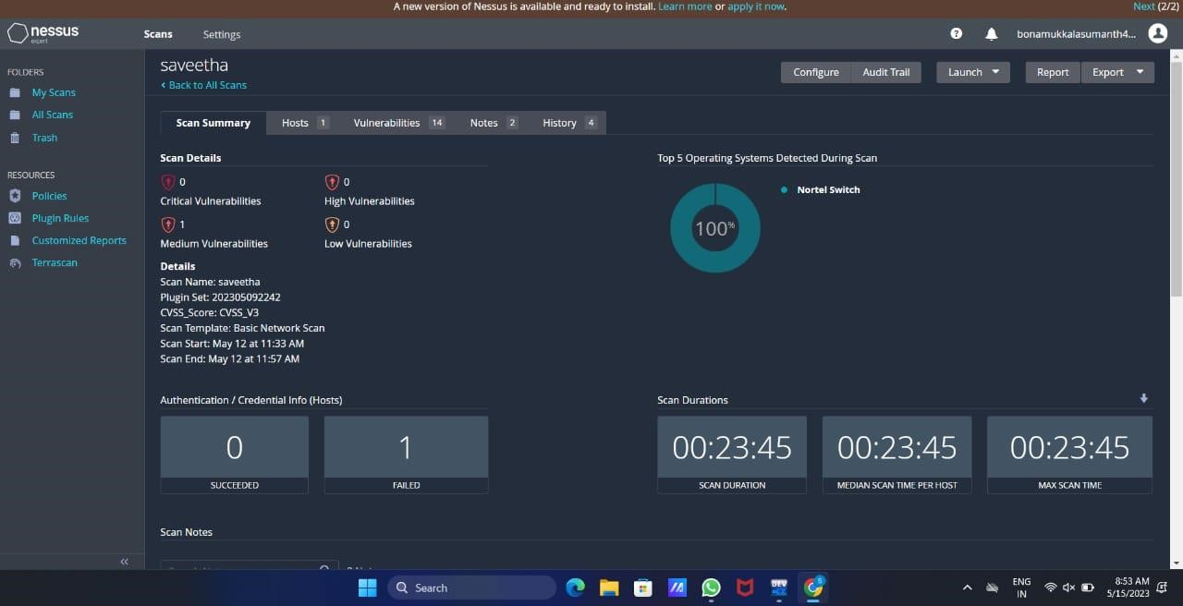

**Result:**

The following experiment is done using Nessus website in windows operating system. I have done this experiment in google chrome of windows operating system.

**Exercise No 3**: **Information gathering using theHarvester**

**Aim:** To demonstrate information gathering using theHarvester **Procedure:**

**STEP 1: Open Terminal in the kali linux**

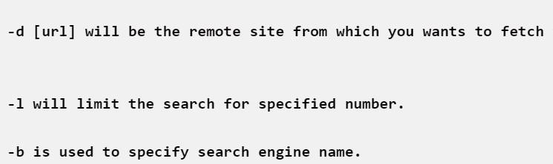

**STEP 2: Run the following command**

**Command: theHarvester -d** [**www.zoho.com**](http://www.zoho.com/) **-l 300 -b all**

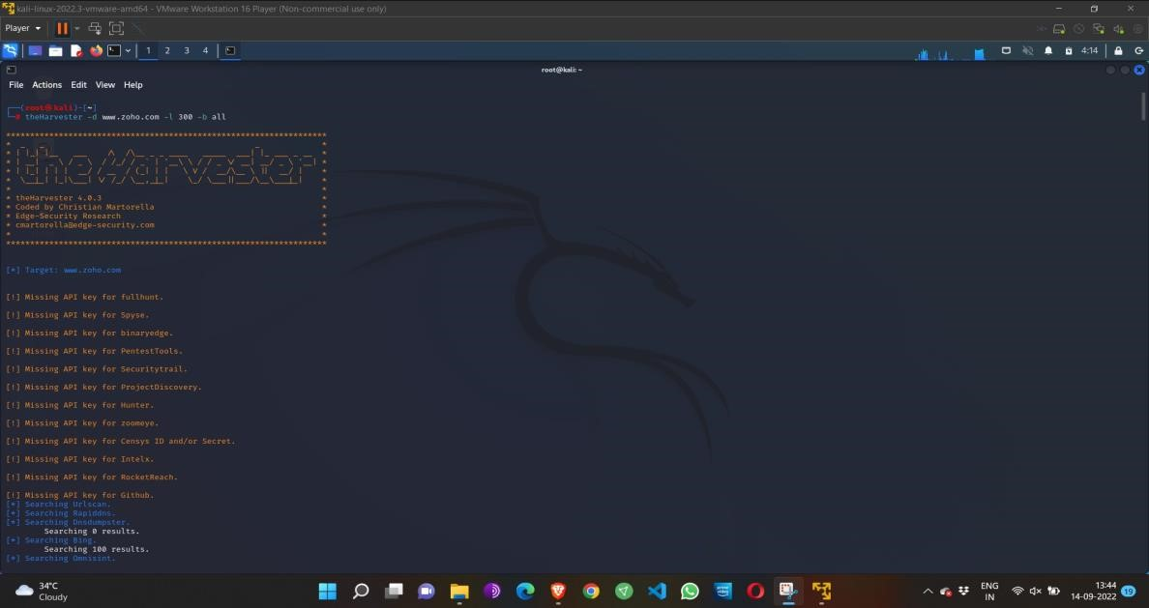

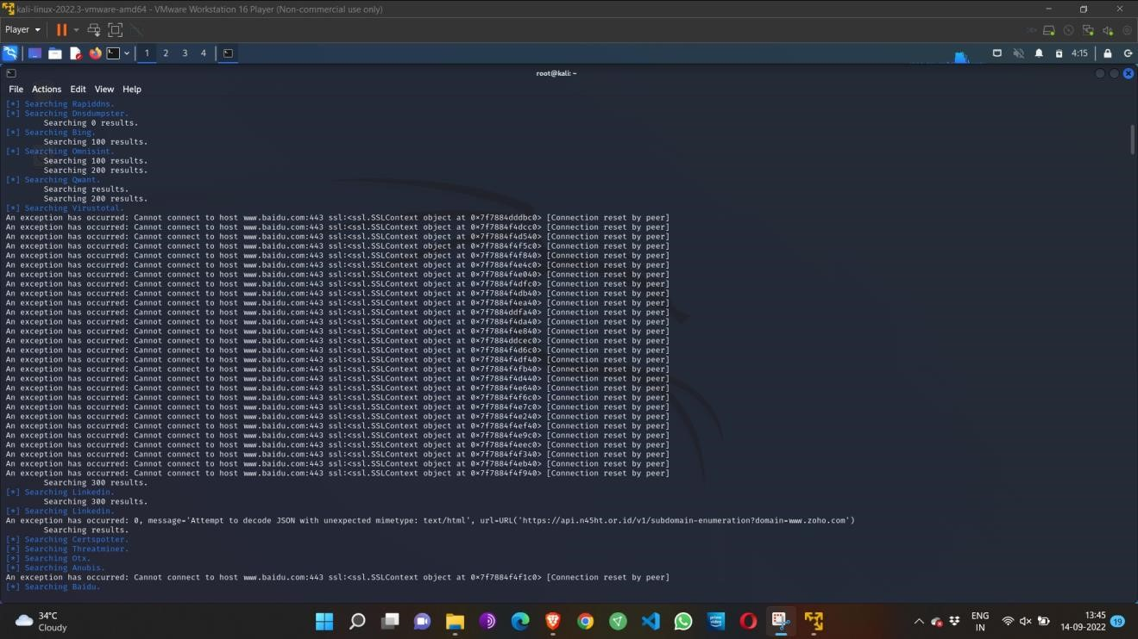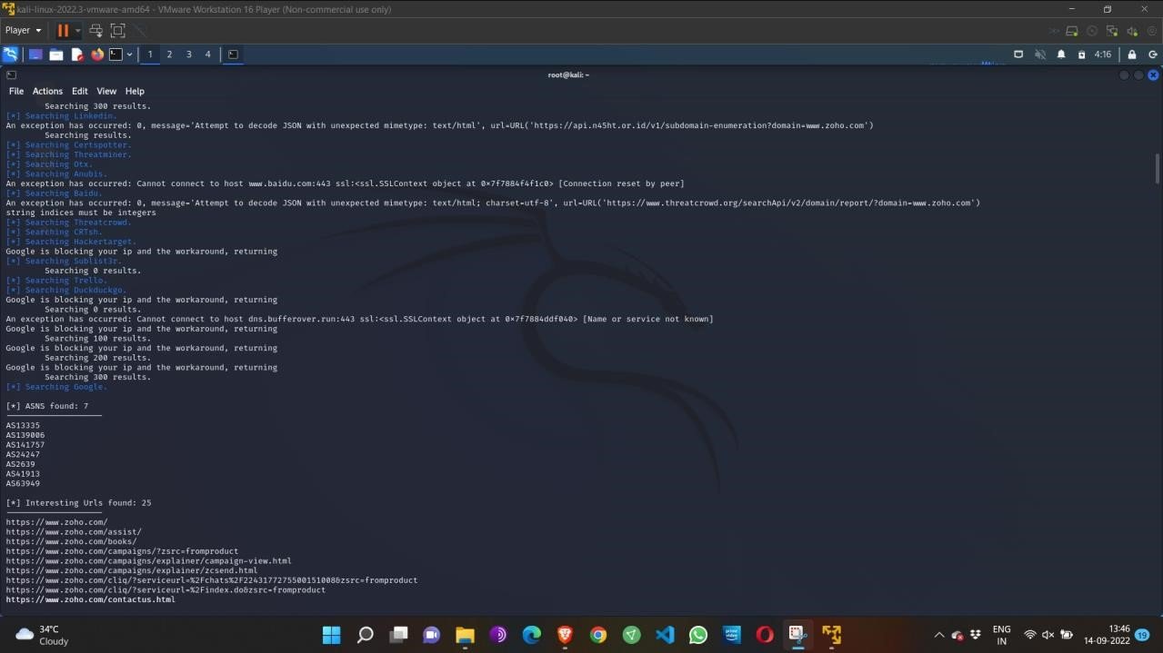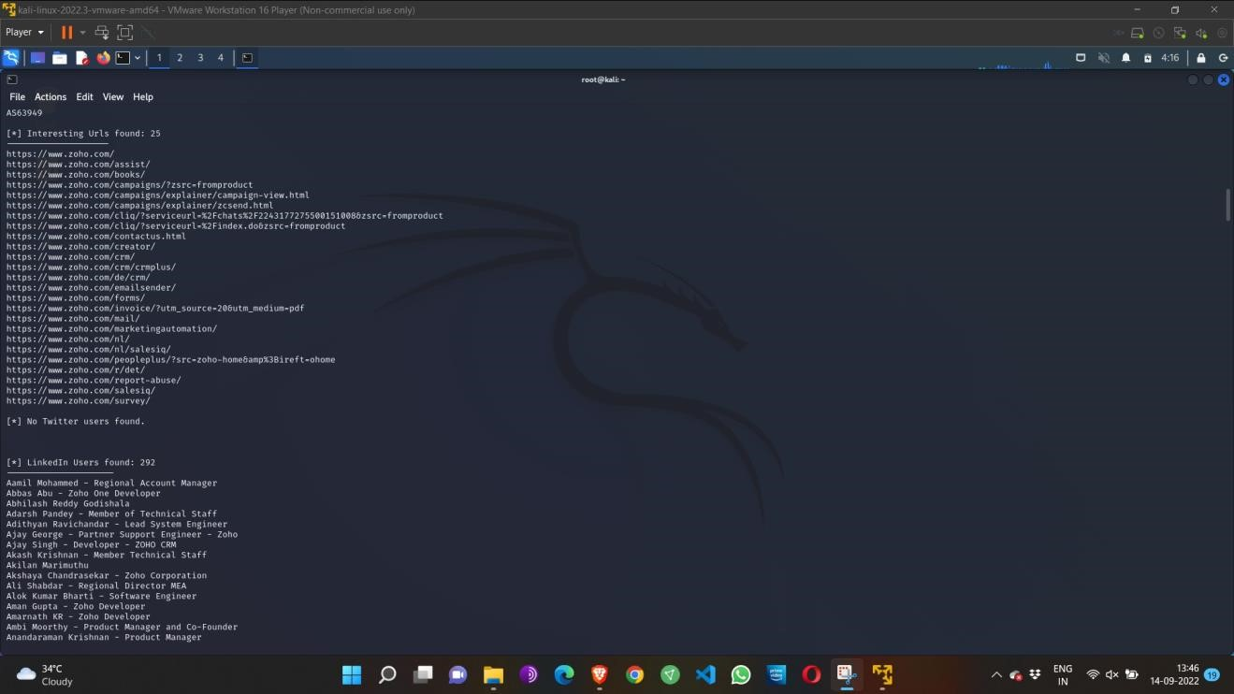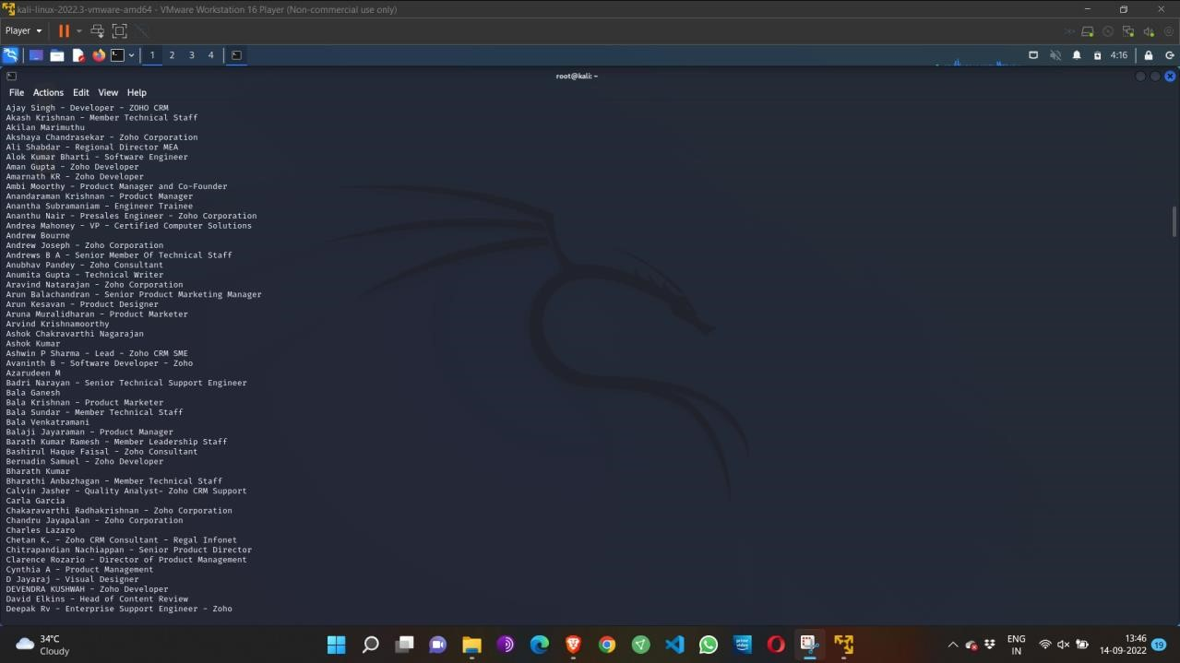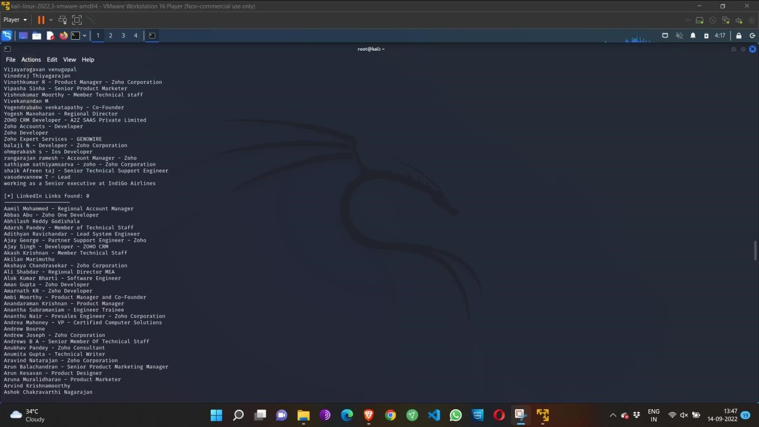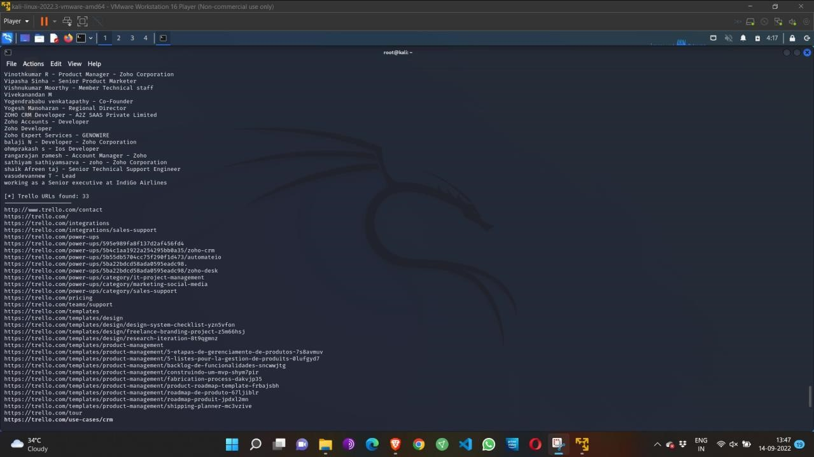

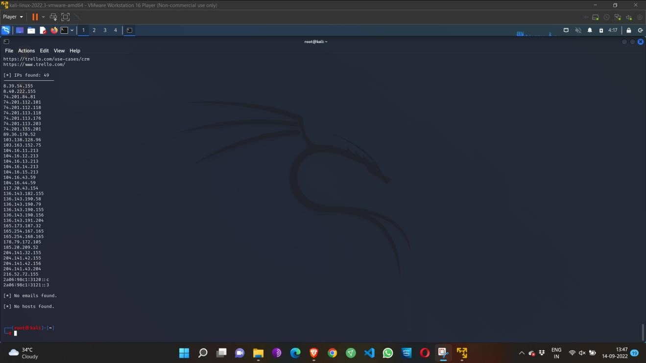

Step 4: run this command “**theHarvester -d** [**www.zoho.com**](http://www.zoho.com/) **-l 300 -b all -f test” and** hit enter to export the result as html file and xml file

Step 5: now close the terminal and navigate the home folder and search for test file .

**Output:**

1)

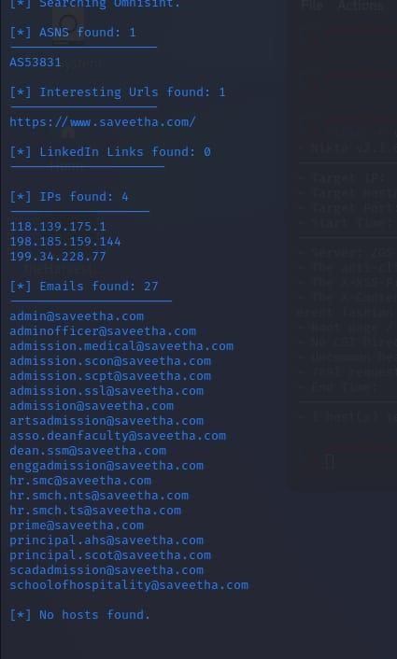

**Result:**

The above-mentioned experiment is done using theHarvester in kali Linux server. The information is gathered using theHarvester.

**Exercise No 4 - Open Source Intelligence Gathering Using OSRFramework**

**Aim:** To Checks for the Existence of a Profile for given user details in different platforms **Procedure:**

Step 1: Log into kali linux machine

Step 2: Launch a command line terminal by clicking on terminal icon from taskbar Step 3: Usufy.py checks for the existence of a profile for given user details in different platforms

**Command:**

Usufy.py -n <Target username or profile name> -p twitter facebook youtube

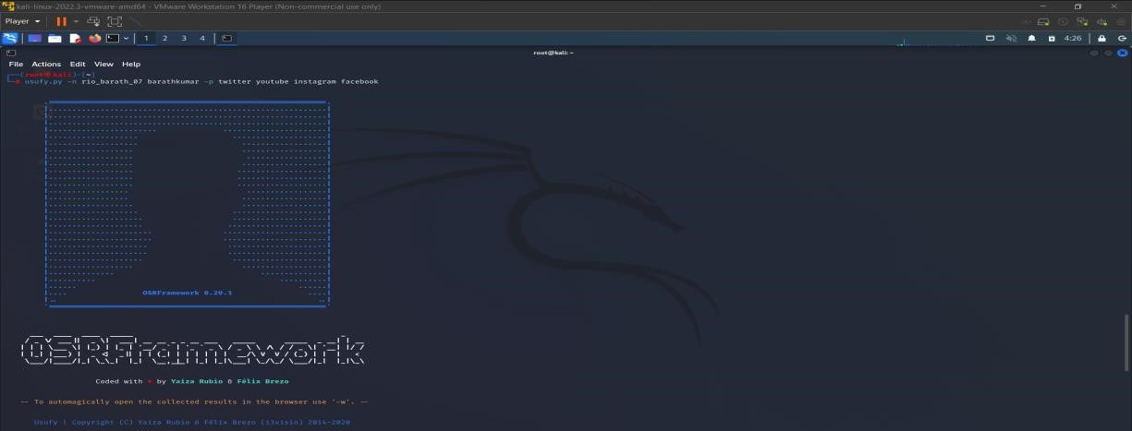

If any error occurs Try this command: **Sudo apt-getupdate**

The usufy.py will search the user details in the mentioned platform and will provide you with the existence of the user

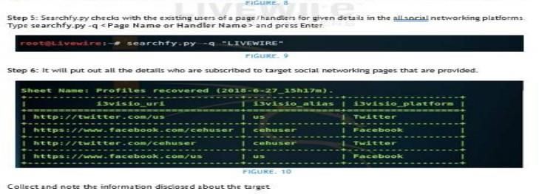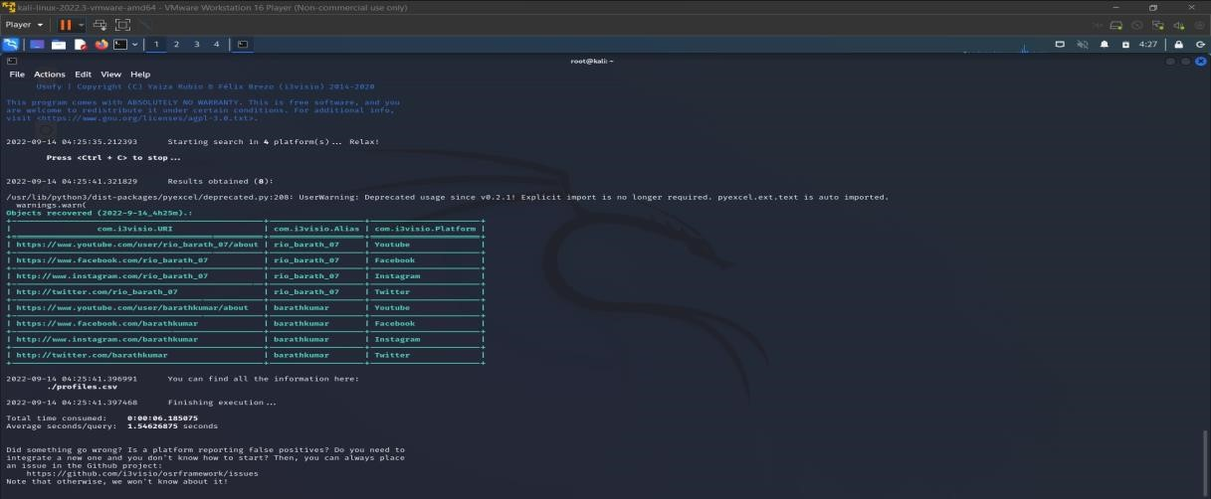

**Output:**

1)

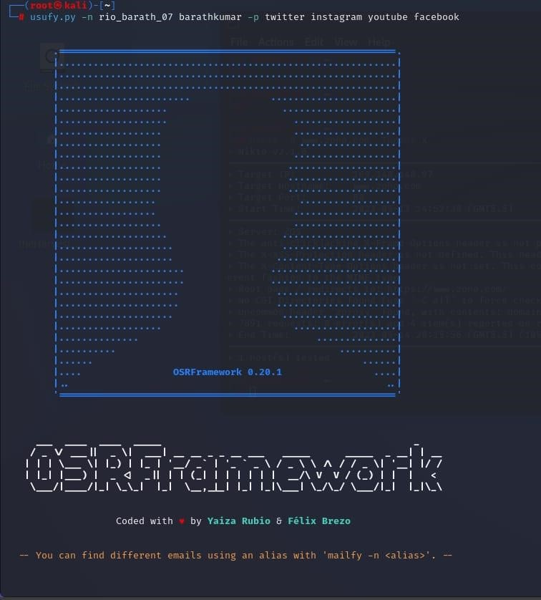

### 2)

**Result:**

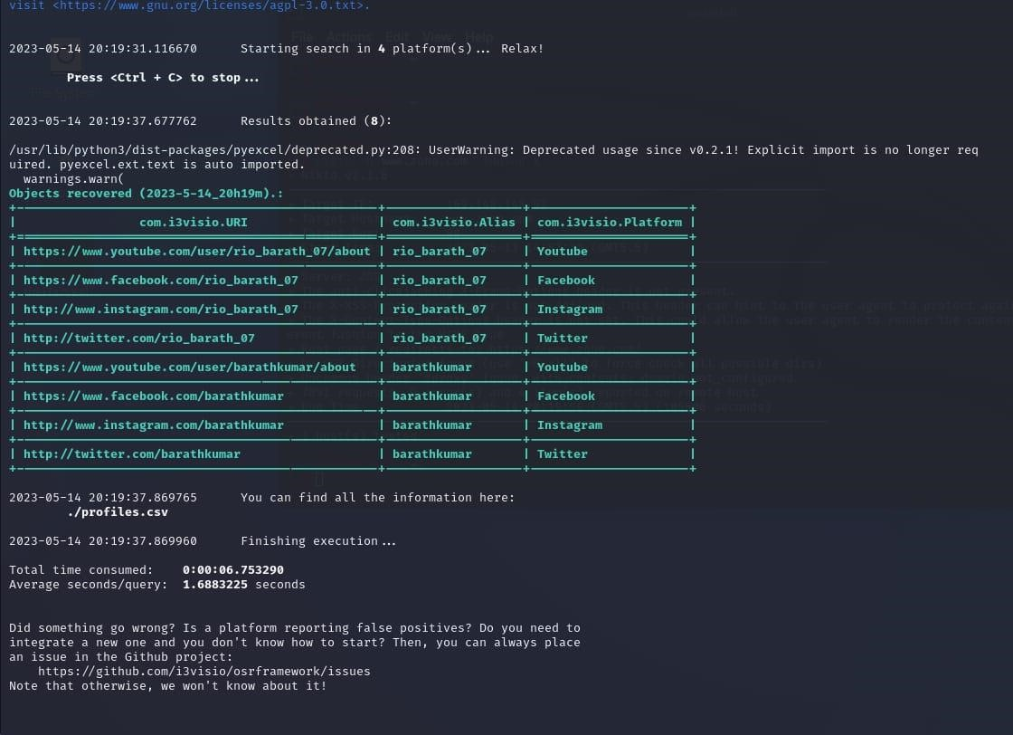

The current experiment is about Open-Source Intelligence Gathering is done using OSR Framework. This experiment is done to check for the Existence of a Profile for given user details in different platforms. This experiment is executed in root terminal using kali linux operating system.

**Exercise NO 5: Use Google and Whois for Reconnaisasance.**

**Aim:** To find out the Whois, DNS Records and Diagonstics for particular website by using Whois search. **Procedure:**

Step1: Open the WHO.is website

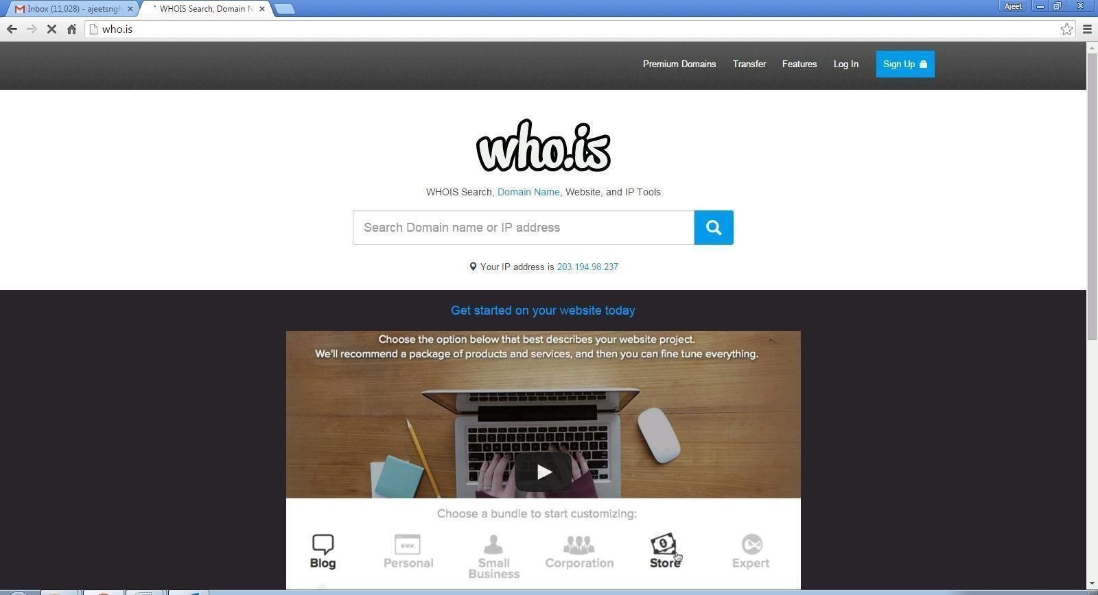

Step 2: Enter the website name in search bar and hit the “Enter button”. Step 3: Show you information about [www.saveetha.com](http://www.saveetha.com/)

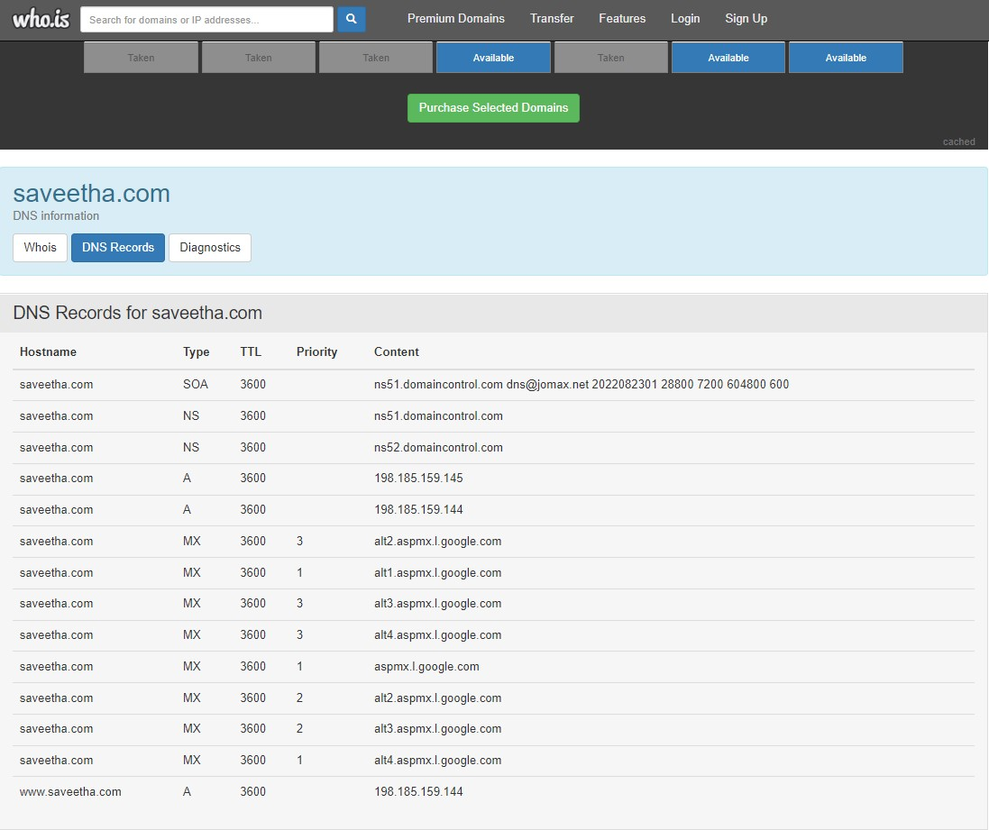

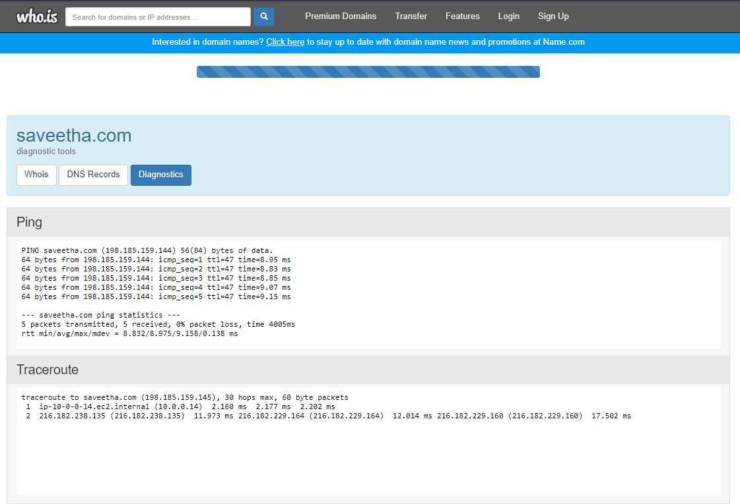

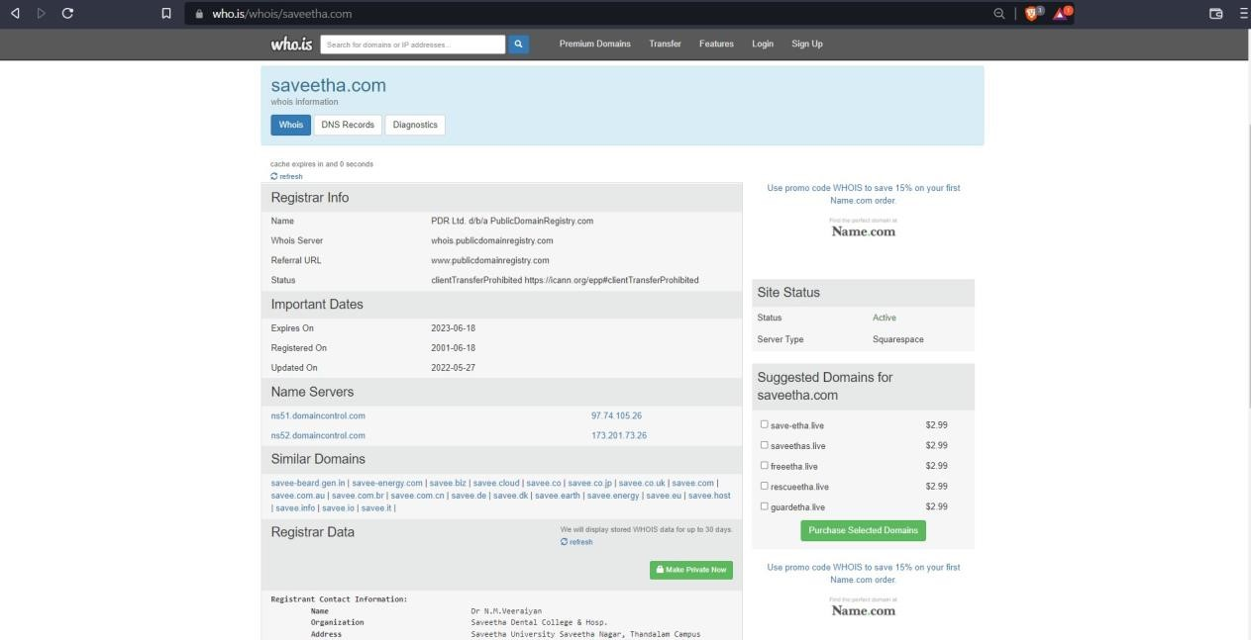

**Output:**

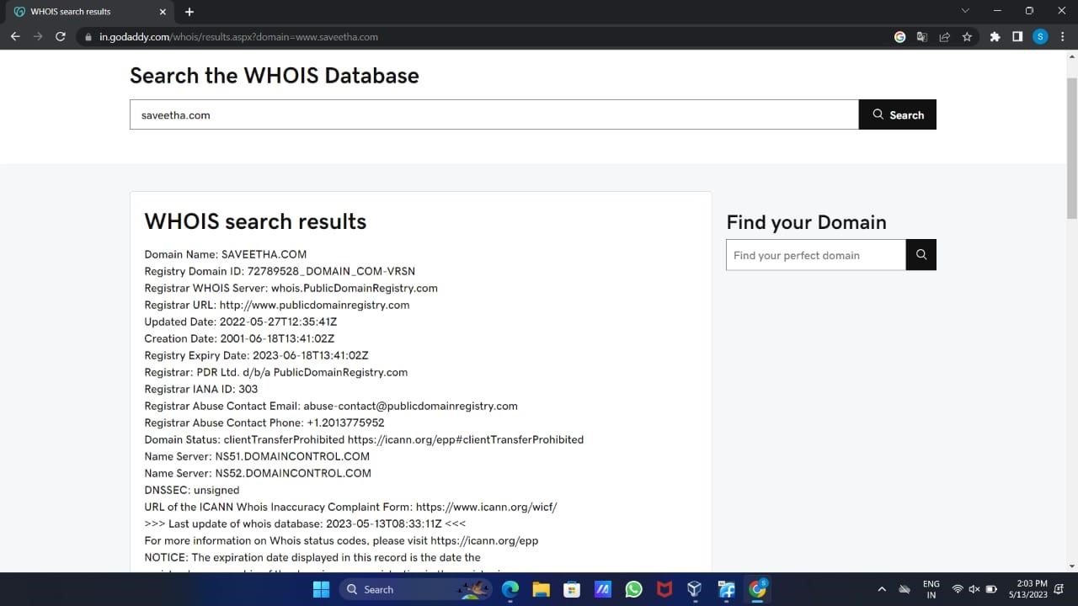

**Result:**

WHOIS is tool to check for the domain names, domain address and IP addresses. This experiment was done using the google and WHOIS.com website. We got the results such as domain name, domain ID, website creation date, name server and so on.

**Exercise No 6: TraceRoute, ping, ifconfig, ipconfig, netstat**

**Aim: Using TraceRoute, ping, ifconfig(LINUX), ipconfig(WINDOWS), and netstat Command.**

**Procedure:**

Step 1: open windows command prompt and Type tracert command and type tracert  [www.saveetha.com -](http://www.saveetha.com/)> “Enter”

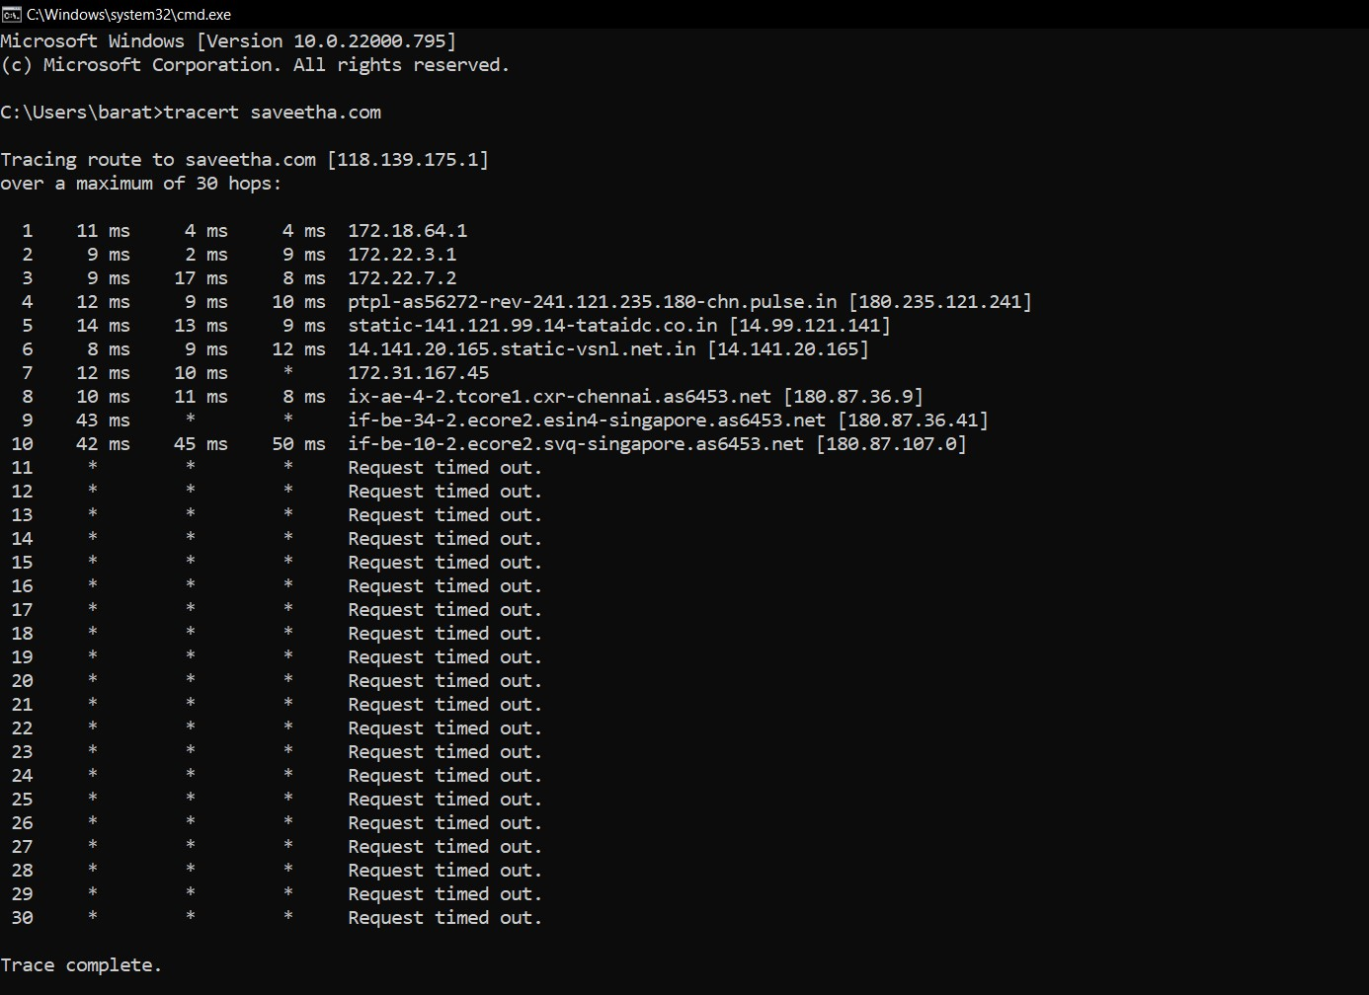

Step 2: Type ping command and type IP Address press “Enter”

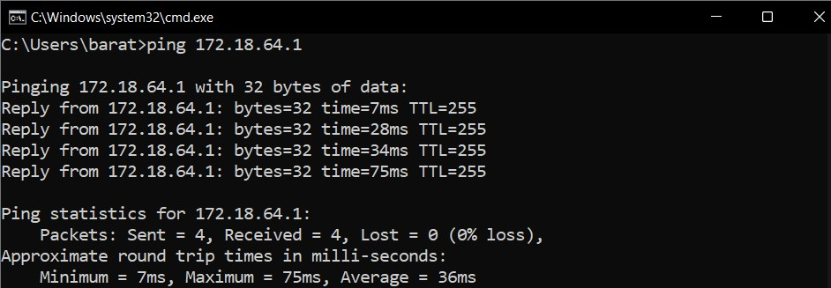

Step 3: Type ifconfig command

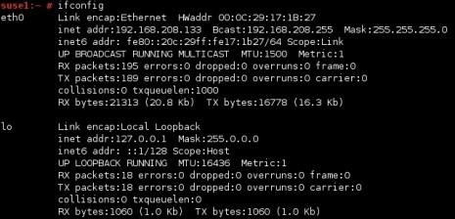

Step 4: Type netstat command

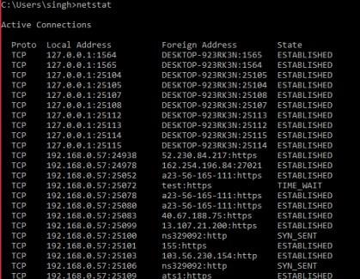

**Output:**

1)

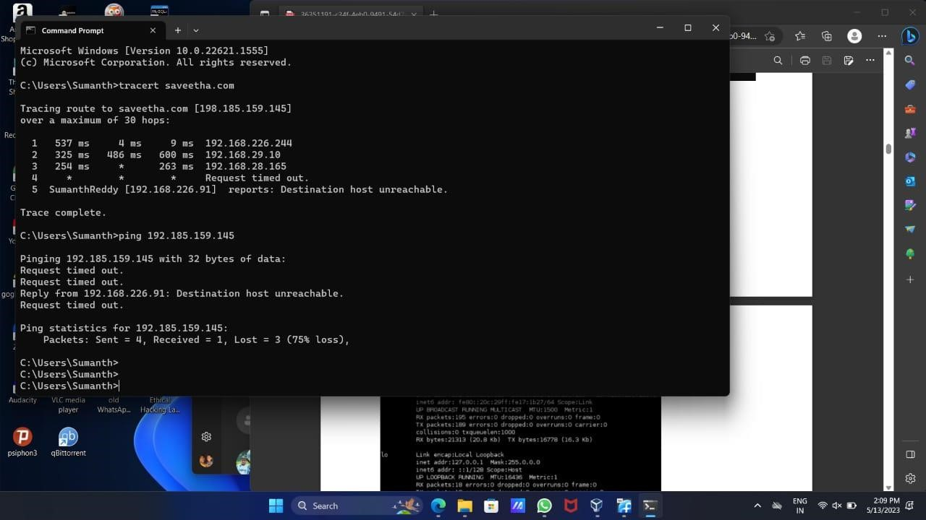

2)

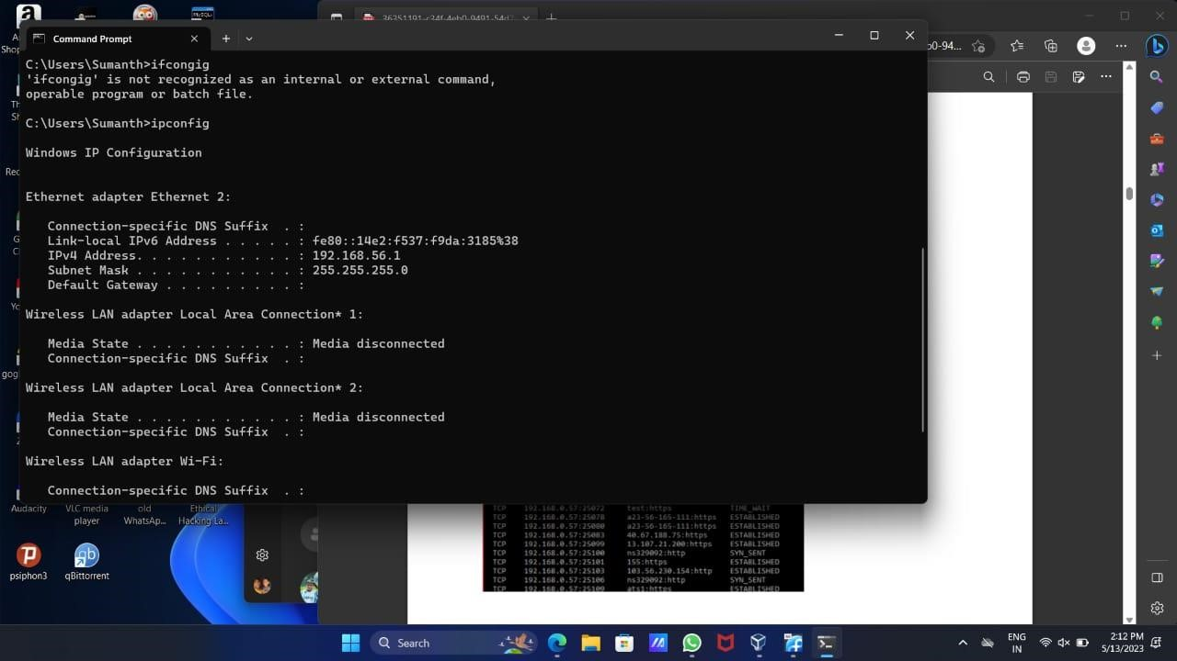

3)

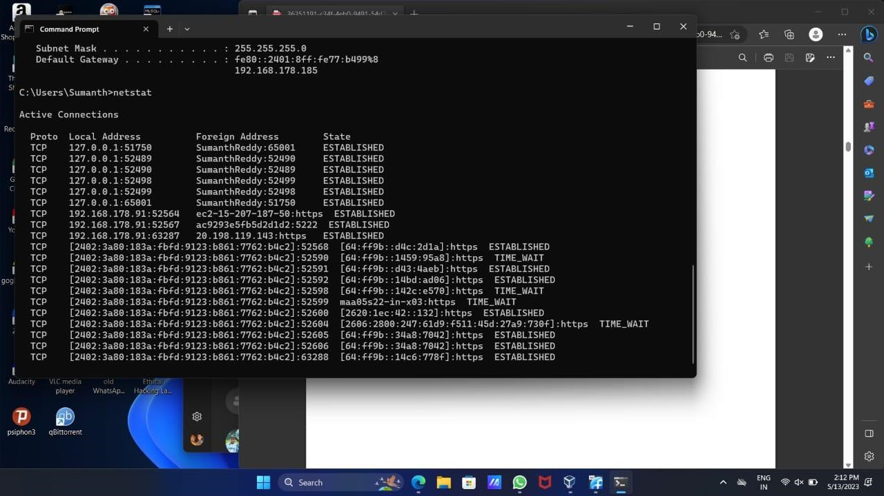

**Result:**

I have carried out the above experiment using Microsoft windows command prompt. I have used the commands TraceRoute, ping, ifconfig, ipconfig, netstat in this experiment. I have got the results for each command like ping, IP addresses, LAN connections.

**Exercise No 7:VULNERABILITY ANALYSIS - CGI Scanning with Nikto**

**Aim:To perform vulnerability Analysis using CGI Scanning with Nikto**

**Procedure:**

Step 1: open a terminal window and type nikto –H and press enter Step 2: Type nikto –h <website> Tuning x and press enter

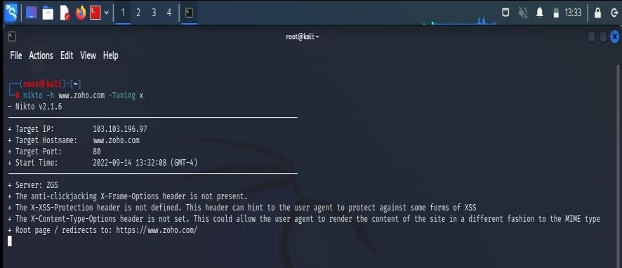

Step 3: Nikto starts web server scanning with all tuning options enabled.

Step4:In the terminal window type “nikto –h <website>-Cgidirs all”and hit enter

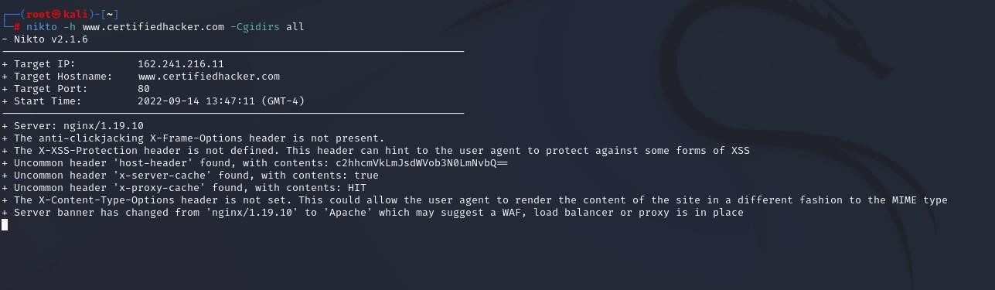

Step 5. Nikto will scan the webserver as it looks vulnerable CGI directories. It scans the webserver and list out the directories

**Output:**

1)

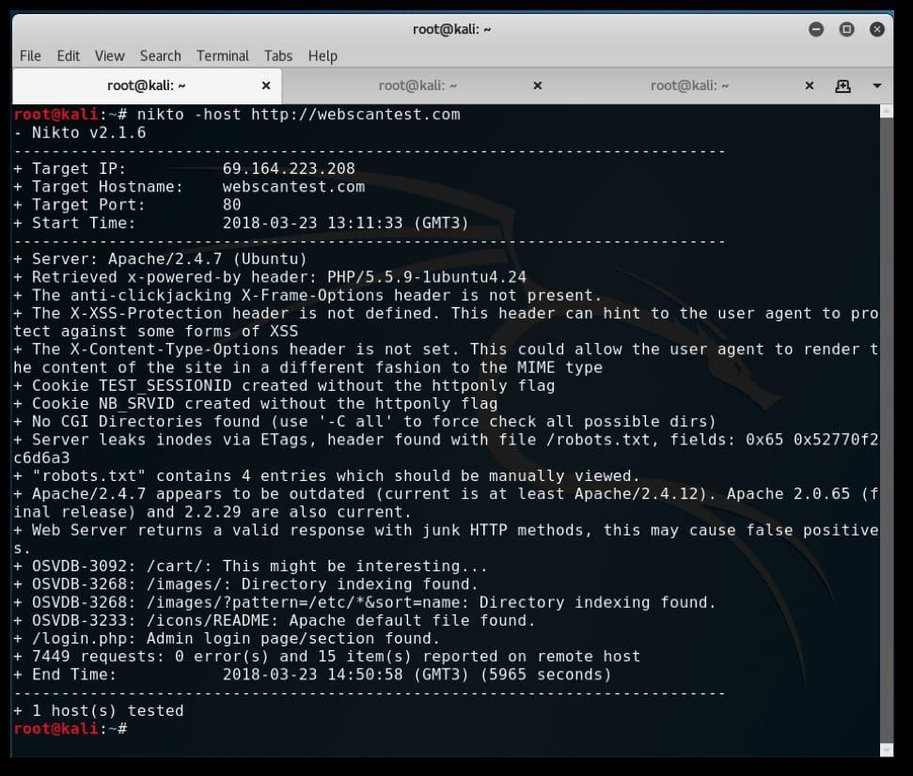

**Result:**

The above experiment is about VULNERABILITY ANALYSIS - CGI Scanning with Nikto. We can retrieve information like server name, headers and etc. This is done in root terminal using kali linux OS.

**Exercise No 8: WireShark sniffer**

**Aim: Use WireShark sniffer to capture network traffic and analyze. Procedure:**

Step 1: Install and open WireShark .

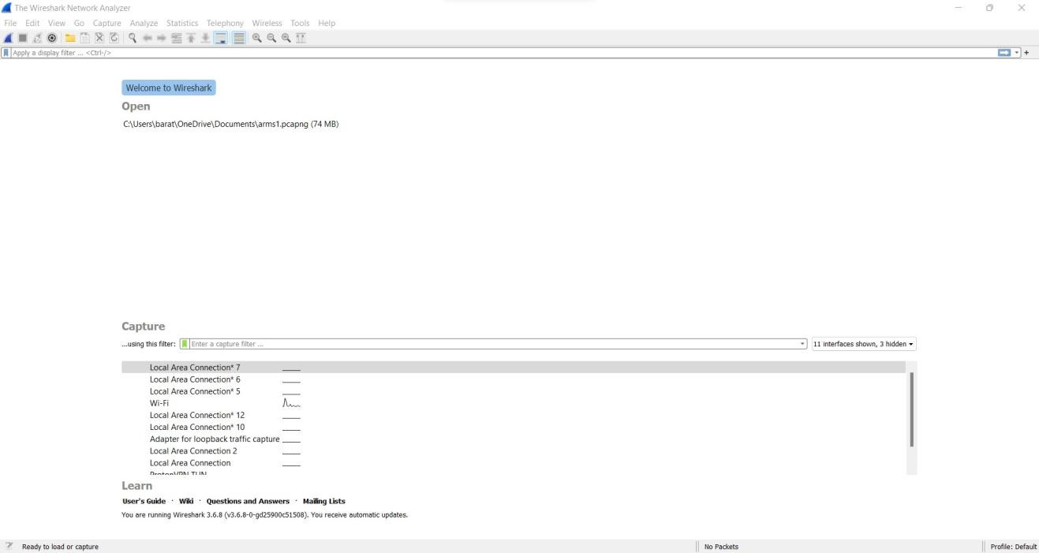

Step 2: Go to Capture tab and select Interface option. Here Wifi connection is chosen

Step 3: The source, Destination and protocols of the packets in the Wifi network are displayed

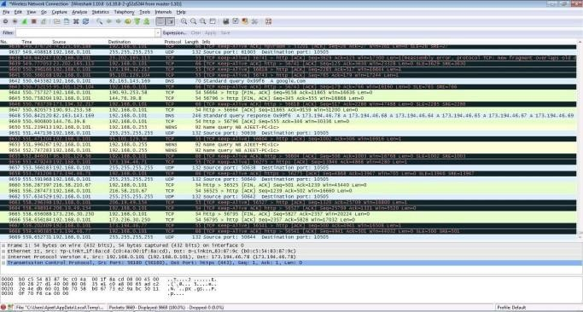

Step 4: Open a website in a new window and enter the user id and password. Register if needed.

Step 5:Enter the credentials and then sign in

Step 6: The wireshark tool will keep recording the packets.

Step 7: Select filter as http to make the search easier and click on apply. Step 9: Now stop the tool to stop recording

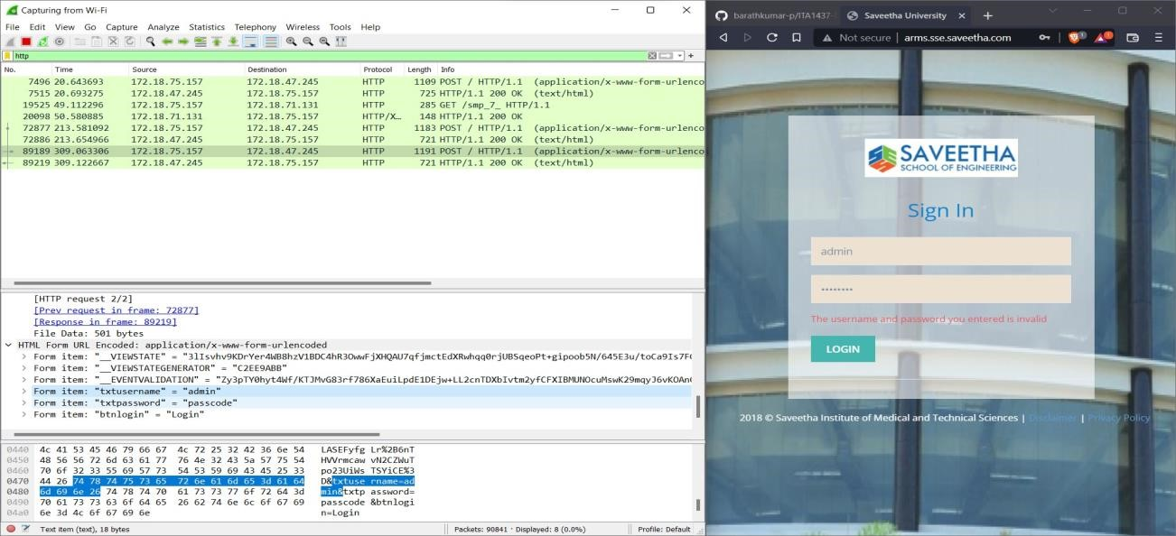

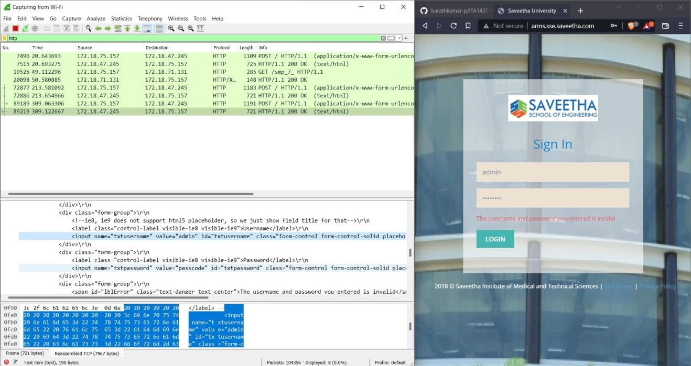

Step 10: Find the post methods for username and passwords

Step 11: U will see the email- id and password that you used to log in.

**Output:**

1)

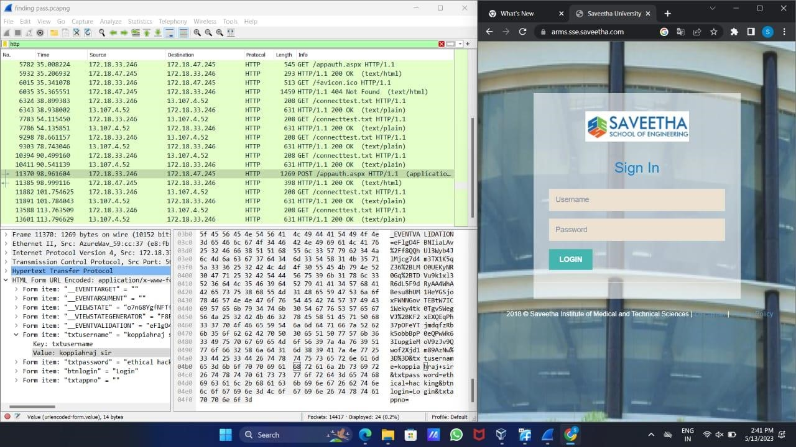

**Result:**

The current experiment is about wireshark sniffer. Using WireShark sniffer, we can capture network traffic and can be able analyze it. This experiment executed using google chrome.

# Ex. No.9 – ENUMERATION - Enumerating information from windows and Samba Host Using Enum4linux

**Requirements:**

* Kali linux running as an attacker machine
* Windows 7 running as virtual machine
* Admin privileges **Procedure:**

1.Start the kali linux machine and open a terminal window

2.Type “sudo apt-get update” command

3.Now type enum4linux-h and hit enter to get help options With the help options conduct the enumeration on target machine

4.In the terminal window type enum4linux -u -p -U and hit enter to run this tool using the user list options

5.Enum4linux starts enumerating the workgroups/domain names first and display the results

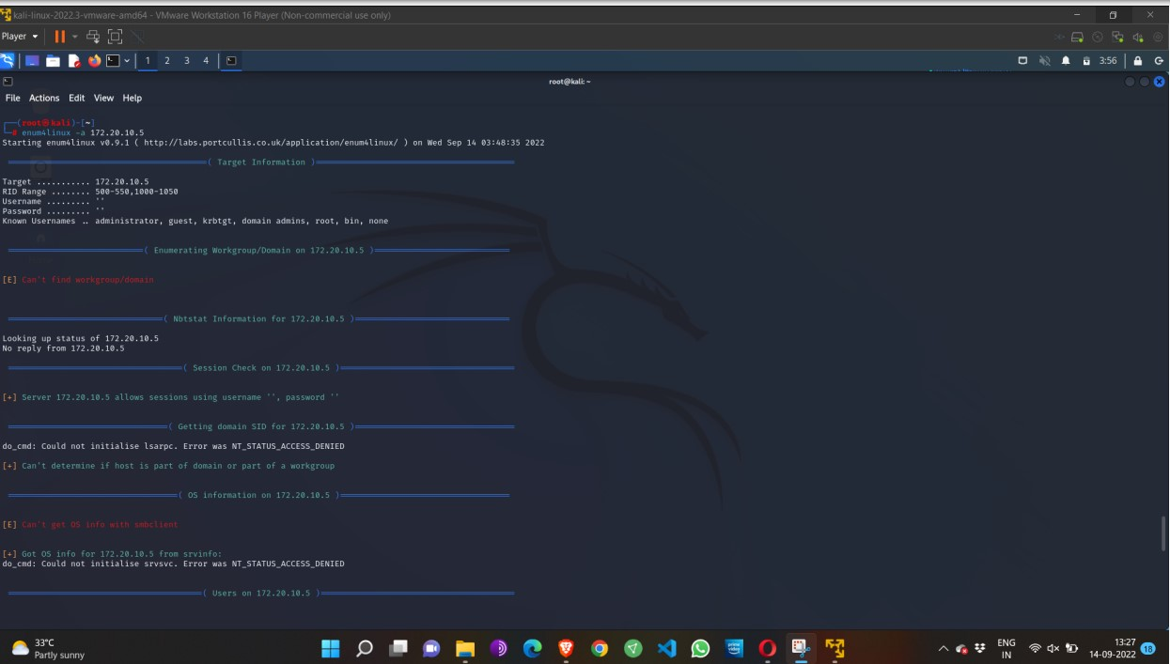6.To enumerate all the information Use this command enum4linux -a.

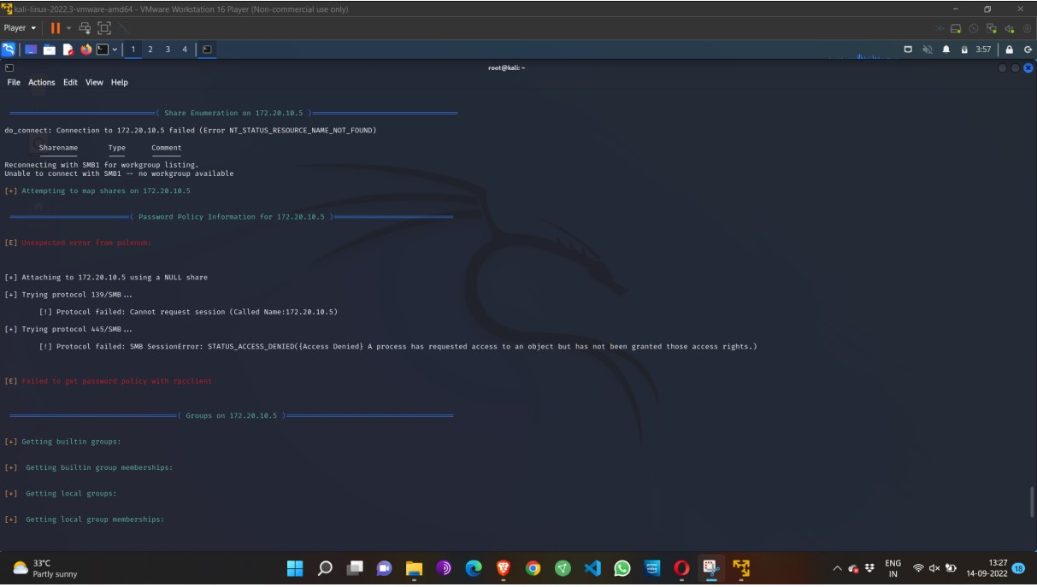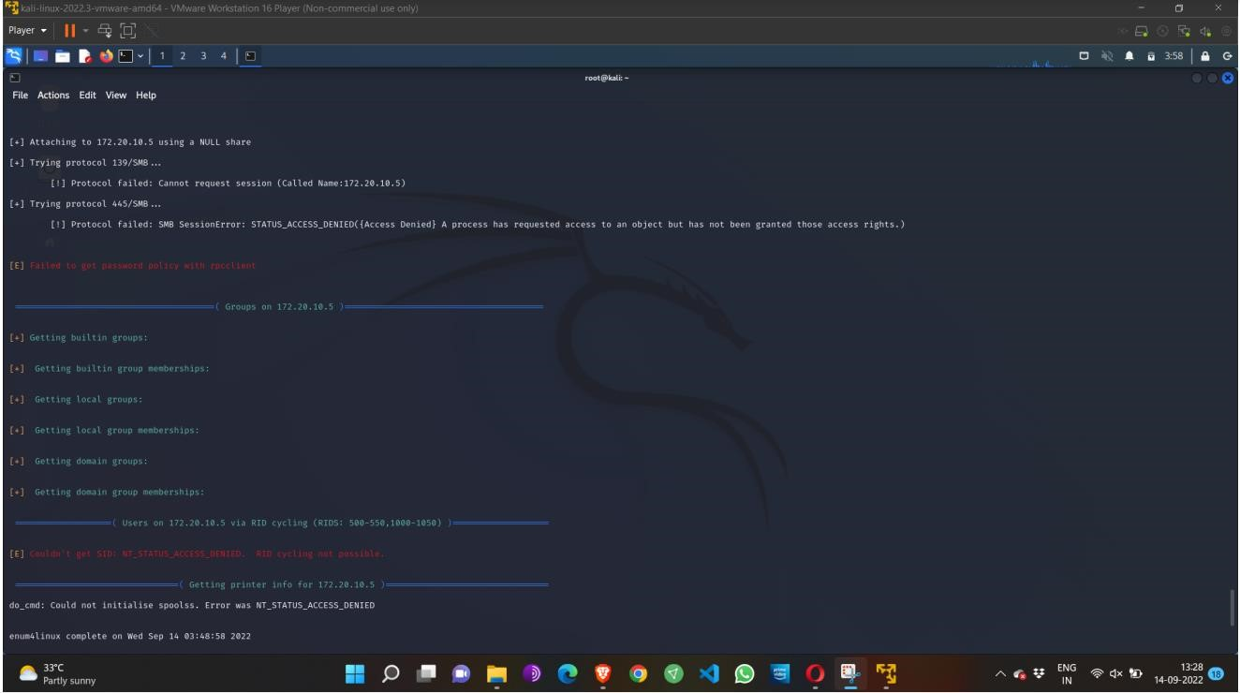

**Output:**

**Result:**

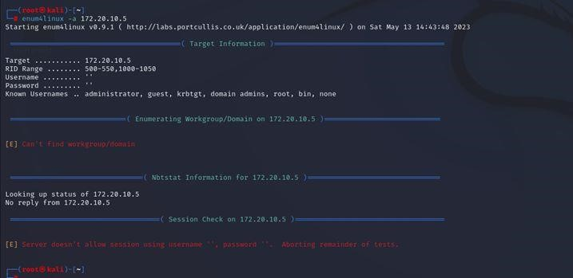 The above experiment is done using enum4linux command. This experiment is about Enumerating information from windows and Samba Host Using Enum4linux. This experiment is carried out in root terminal using kali linux Operating System.

## EX.NO: 10 BATCH FILE EXECUTION

**AIM:**

To create a Windows batch file.

**PROCEDURE:**

**Step 1:** Open a text file, such as a Notepad or WordPad document.

**Step 2:** Add your commands, starting with @echo [off], followed by, each in a new line, title [title of your batch script], echo [first line], and pause.

**Step 3:** Save your file with the file extension BAT, for example, test.bat.

**Step 4:** To run your batch file, double-click the BAT file you just created.

**Step 5:** To edit your batch file, right-click the BAT file and select Edit. And here's the corresponding command window for the example above:

**1.Create a New Text Document:**

A batch file simplifies repeatable computer tasks using the Windows command prompt. Below is an example of a batch file responsible for displaying some text in your command prompt. Create a new BAT file by right-clicking an empty space within a directory and selecting New, then Text Document.

**1.CODE:**

Double-click this New Text Document to open your default text editor. Copy and paste the following code into your text entry:

**>> @echo off**

**>> echo hello**

**>> Pause**

**>> echo This is new**

**>> echo this is second one >> pause**

**1. TO SAVE a BAT File**

The above script echoes back the text "Welcome to batch scripting!" Save your file by heading to File > Save As, and then name your file what you'd like. End your file name with the added BAT extension, for example test.bat, and click OK. This will finalize the batch process. Now, double-click on your newly created batch file to activate it.

**2.To RUN as BAT File**

Once you'd saved your file, all you need to do is double-click your BAT file. Instantly, your web pages will open. If you'd like, you can place this file on your desktop. This will allow you to access all of your favorite websites at once.

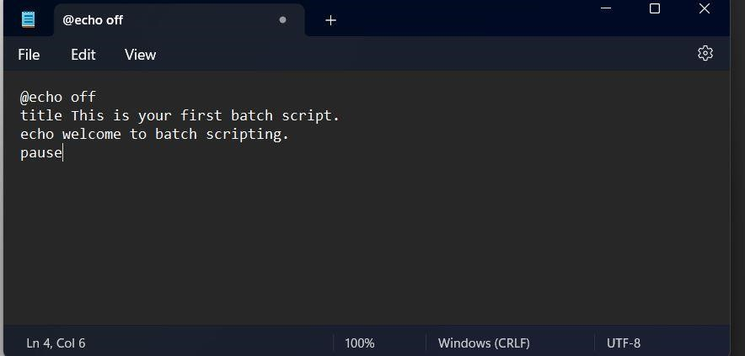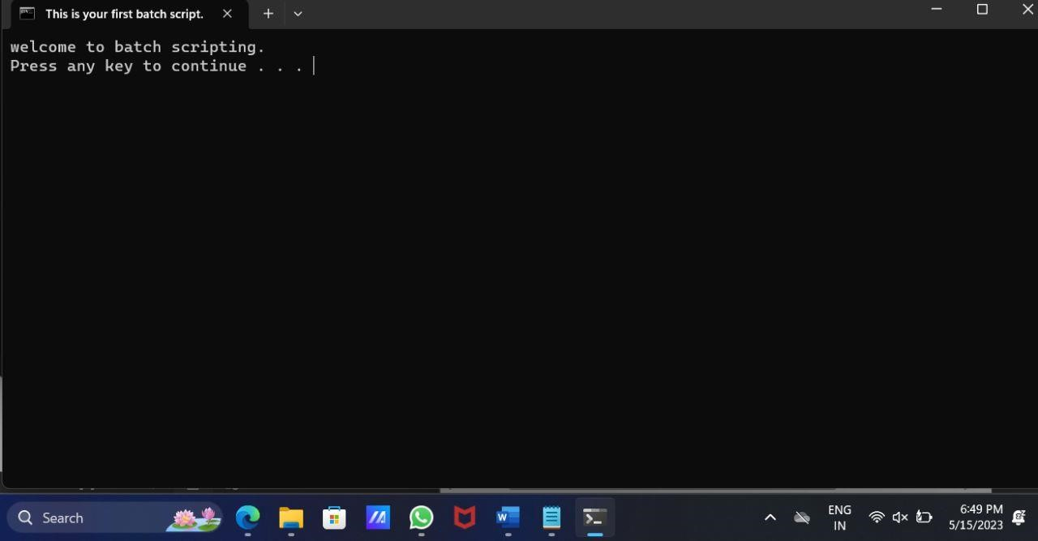**OUTPUT:**

**Result:**

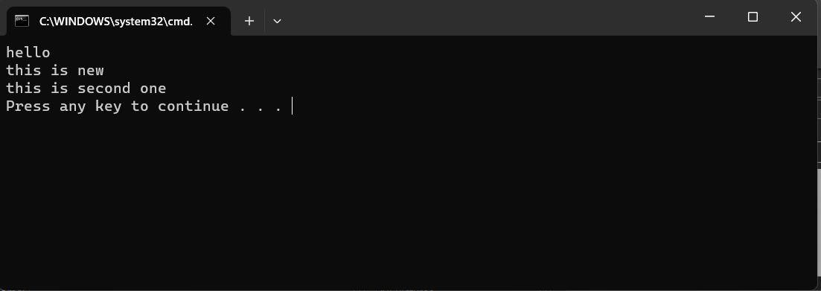 The above experiment is carried out using windows command prompt. The main

aim of this experiment is to create a windows batch file using batch file extension. After this experiment, I was able to create a windows batch file using sufficient data.